Name**:** PUNEET KUMAR

ID**:**  28975

Batch**:**  **25VID1340_DC_Batch2**

Date**:**  17/06/2025

Training Program**: Data Center**

# **Failover clustering –capstone project**

**Failover Clustering**

**Failover Clustering in Windows Server 2019** is a feature that allows multiple servers (nodes) to work together to provide high availability (HA) for services and applications. If one server fails, another server in the cluster automatically takes over — ensuring minimal downtime.

**Key Concepts of Failover Clustering**

1. **Failover Cluster:** A group of independent servers (nodes) working together to increase availability.
2. **Cluster Node:** A server that is a member of the failover cluster.
3. **Cluster Resource:** Services or applications like File Server, SQL Server, VMs, etc., that are made highly available.

1. **Cluster Shared Volumes (CSV):** Shared disks that multiple cluster nodes can access simultaneously.

**Setup Virtual Mechines**

**Step 1 – Create the Base Windows Server 2019 VM**

1. Open **VMware Workstation**.
2. Create a new VM:
   1. RAM: **8 GB**
   2. HDD: **80 GB**
   3. Network Adapter: **NAT**   
      **d. Processors : 2**

1. Install Windows Server 2019.
2. Install **VMware Tools**.
3. Disable the firewall.
4. Rename the computer (e.g., win19base) and **reboot**.
5. Verify changes and shut down the VM.

**Step 2 – Clone the Base OS**

1. Right-click on the base VM → **Manage > Clone**  
   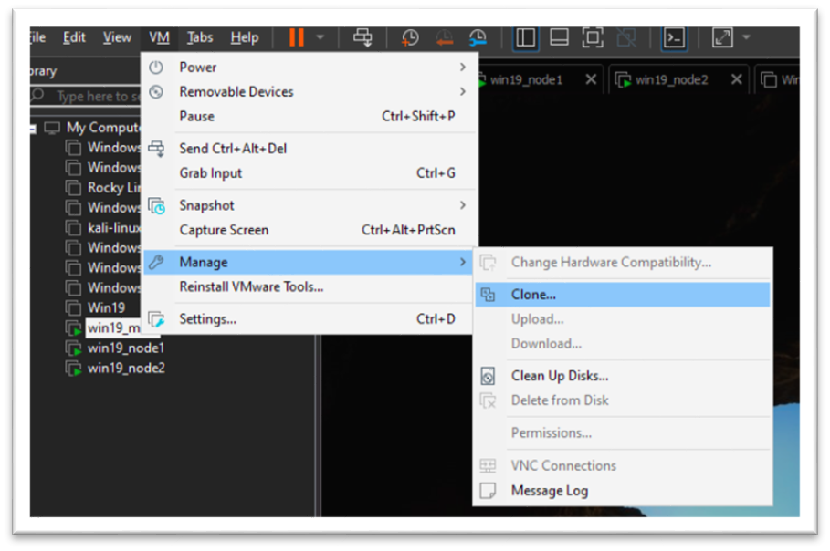

Choose **Current State of VM** → Next.

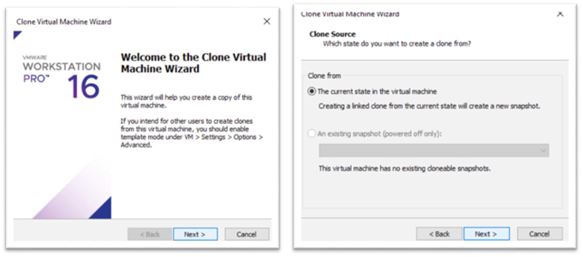

1. Select **Full Clone**:

• Name: win19_main

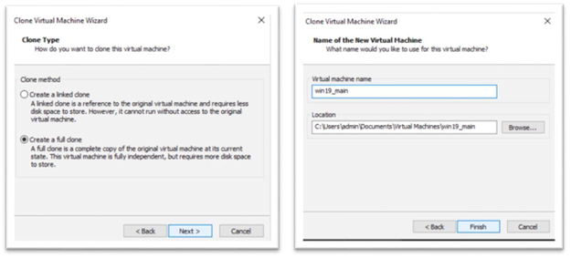

1. **Now Create 2 more VMs name that machine win19_node1 and win19_node2**

**Step 3 – Setup Main Server**

1. **Set Static Ip to 192.168.1.50**
2. **Rename the Os to win19main**

**Install AD DS and DNS Roles**

1. **Server Manager > Add roles and features > Server Roles**
2. **Select Active Directory Domain Services and DNS Server and install**

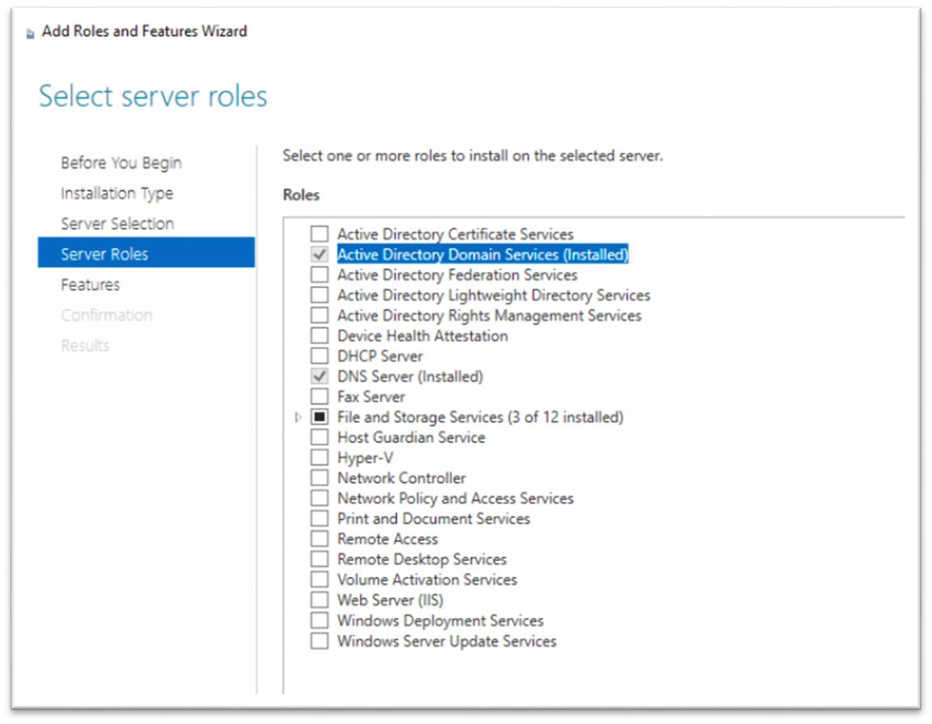

**Promote to Domain Controller**

1. **Notifications > Promote this server to a domain server > Add a new forest > set password > and Install**
2. **After Install Reboot Once**

**Create A Domain User**

1. **Server Manager > Tools > Active Directory Users and Computer > Expand**

**Domain > Right Click on user > new > User**

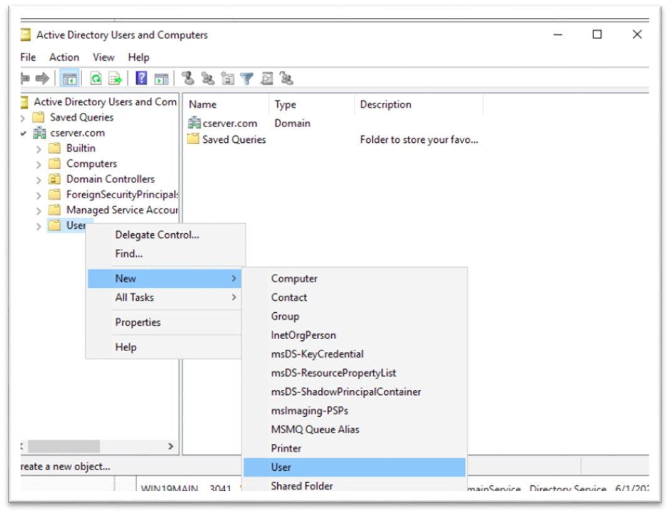  
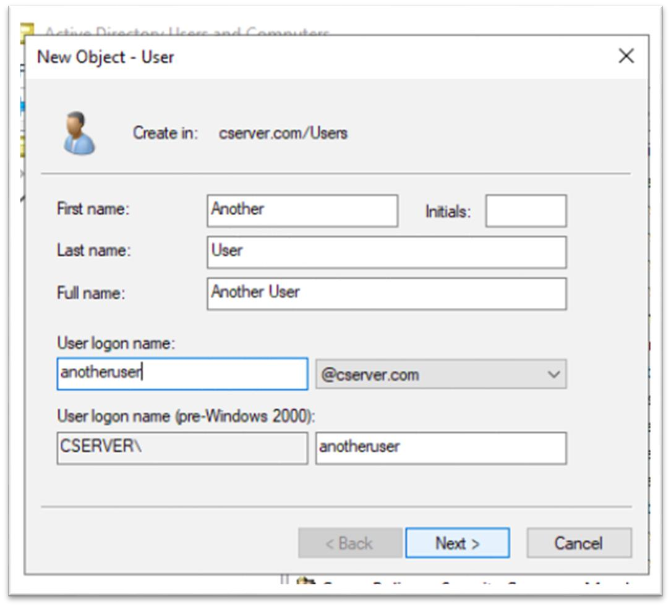

**Set Password and select User cannot change password and Password never expire and next and finish**

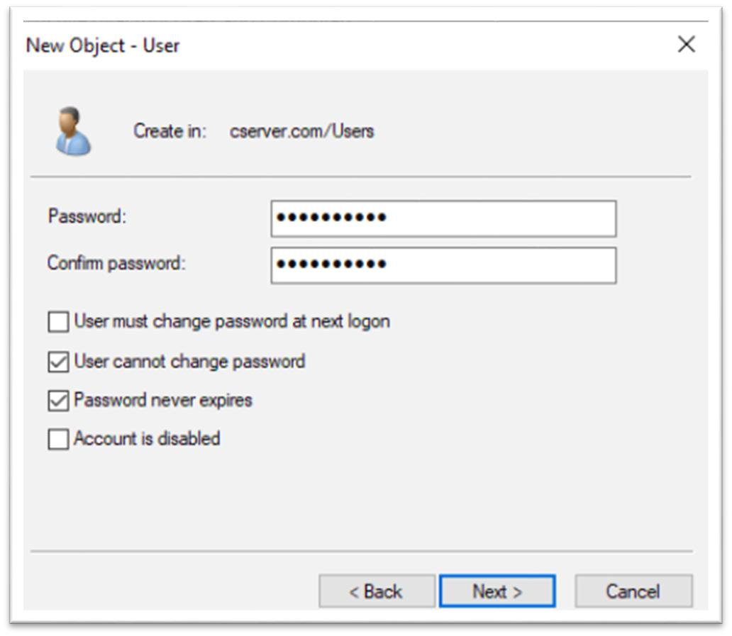  
**Go to Properties of newly created user > Member of and click on add**

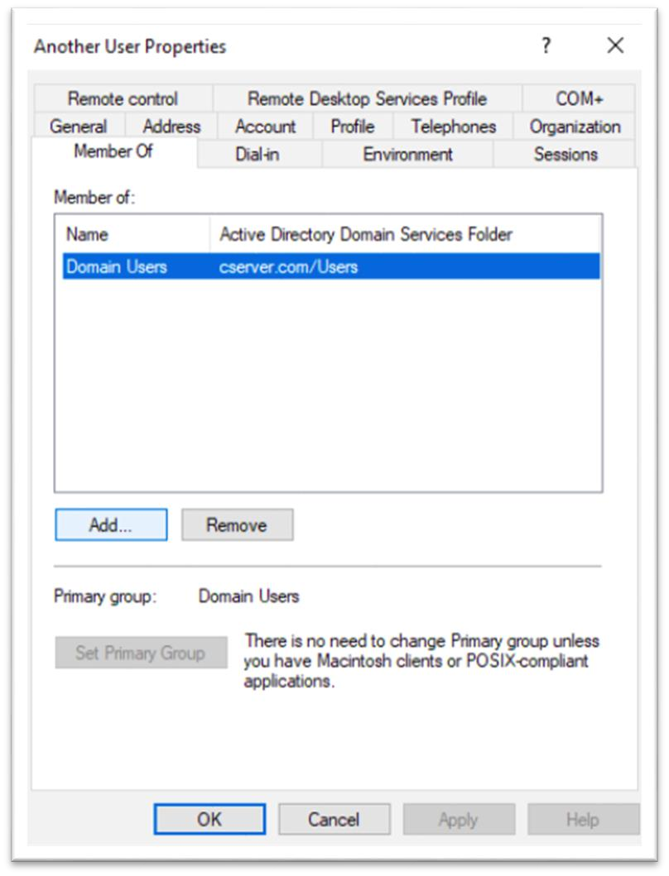  
**Enter Object name to Domain > Check Name > Select Domain Admin > OK**

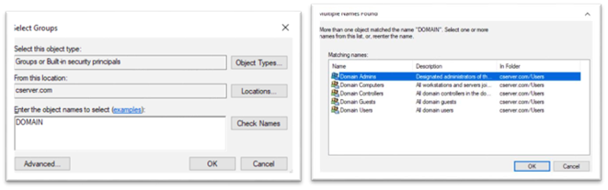

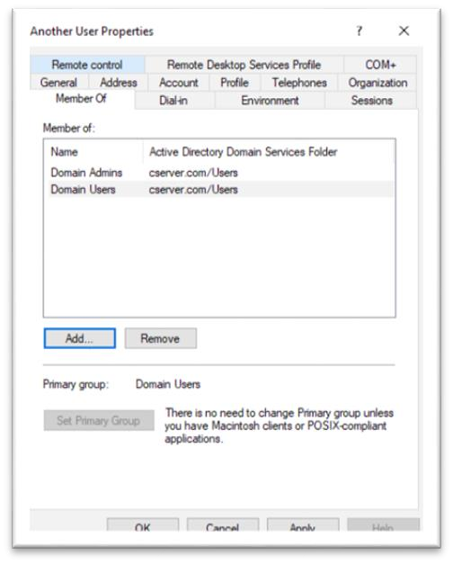

**Setup iSCSI Target on Main Server**

**After that Go to Server Manager > File and Storage Services > ISCSI**

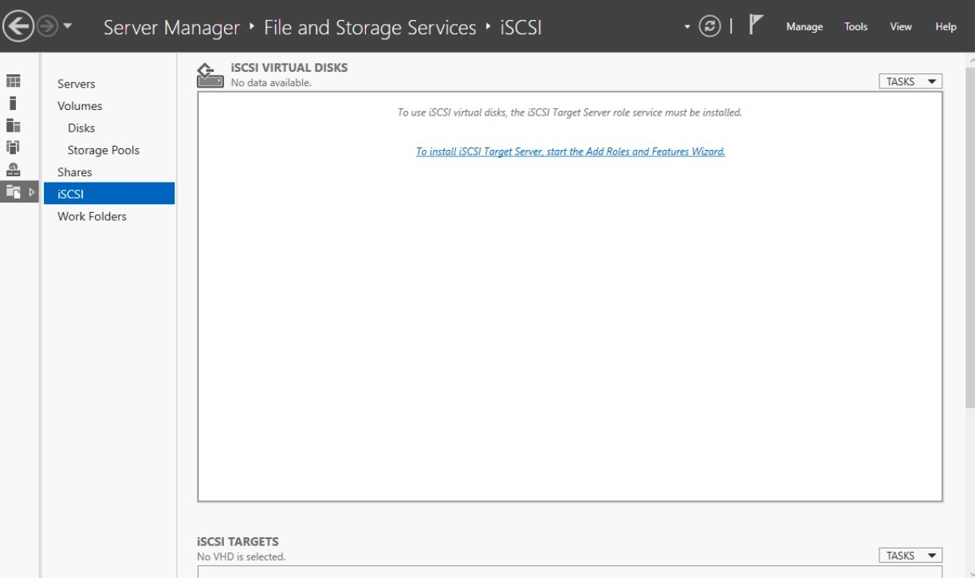

**Install the required features for iscsi and reboot once**

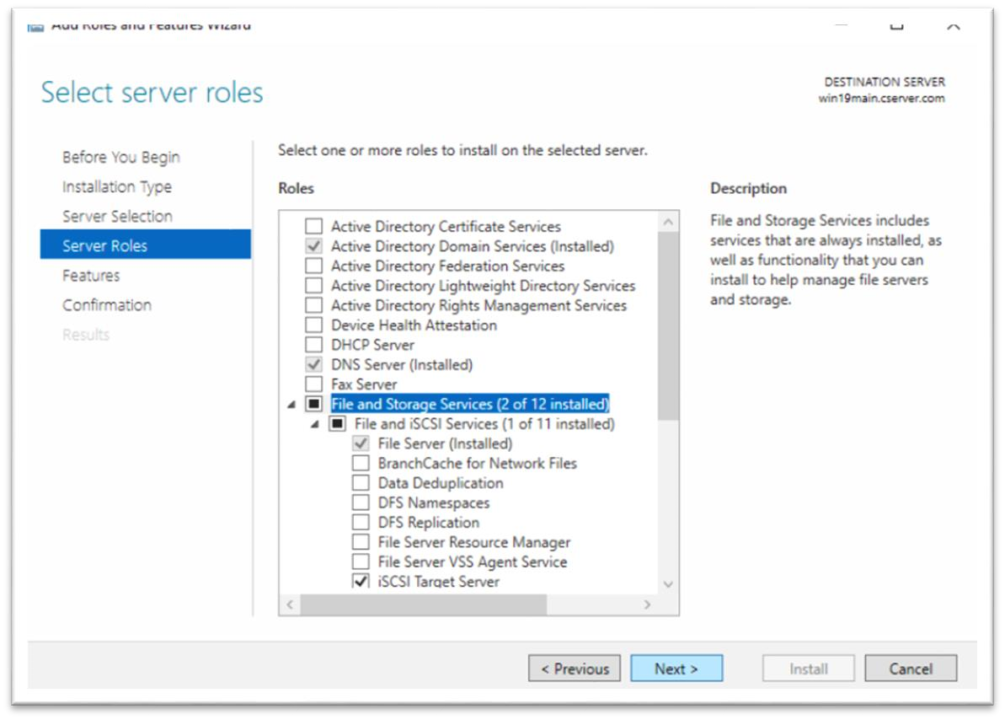

**After Reboot Set Virtual disk name > Set virtual disk size and set dynamic spending > new iscsi > name target name**

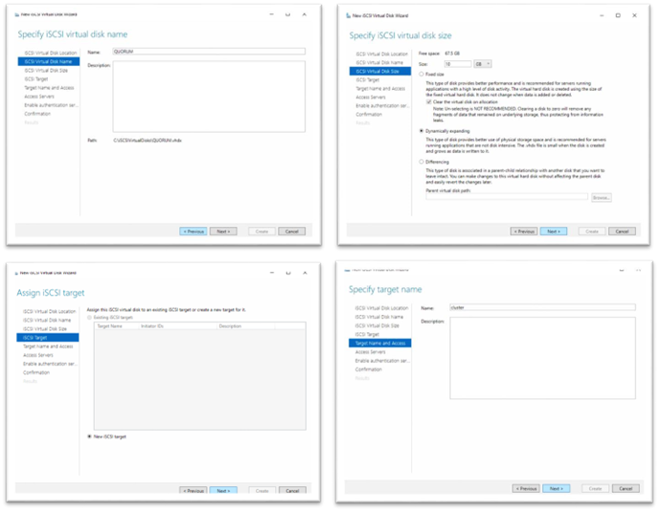

Click on add   
  
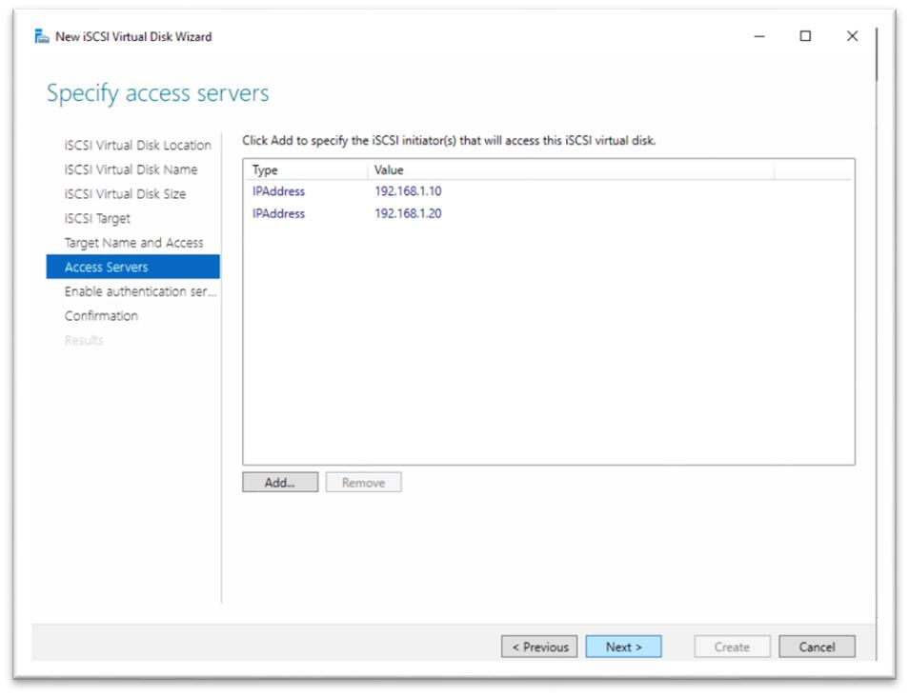

**Set type IP Address and set the value 192.168.1.10**

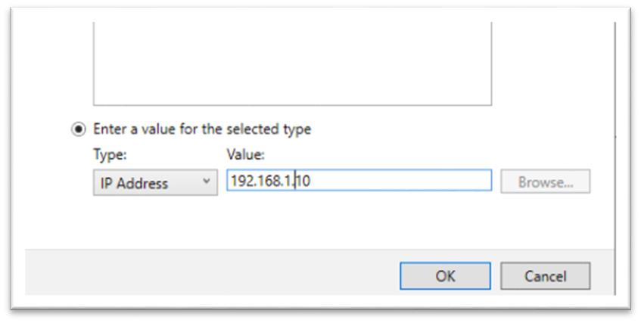  
**After that create another iscsi and set the storage and select existing iscsi target and create with ip – 192.168.1.20**

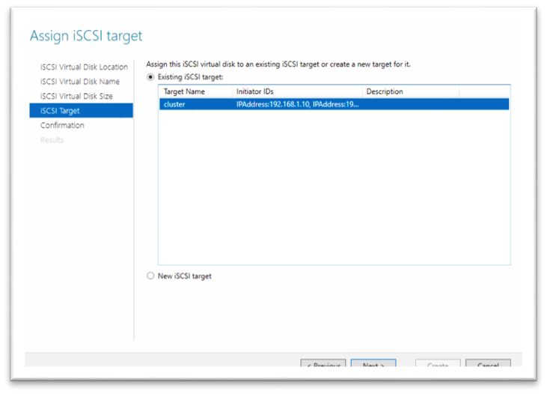  
**Step 4 – Setup Node 1 and node 2 servers**

1. Run **Sysprep**:
   1. **C:\Windows\System32\Sysprep\sysprep.exe**
   2. Select **Enter System** **Out-of-Box Experience (OOBE)** and Generalize c. Reboot

**After That reboot both the os accept the license and set password**

1. **After reboot set Static ip for node1 192.168.1.10 and node2 192.168.1.20**
2. **Default gateway set to 192.168.1.1 in both the os**
3. **And dns to 192.168.1.50**
4. **Server Manager > Add roles and feature > Features > Failover Clustering > Install (Both OS)**  
     
   **Step 5 – Setup Failover cluster**
5. **Open Any of node os**
6. **Server Manager > Failover Cluster Manager > validate Configuration**
7. 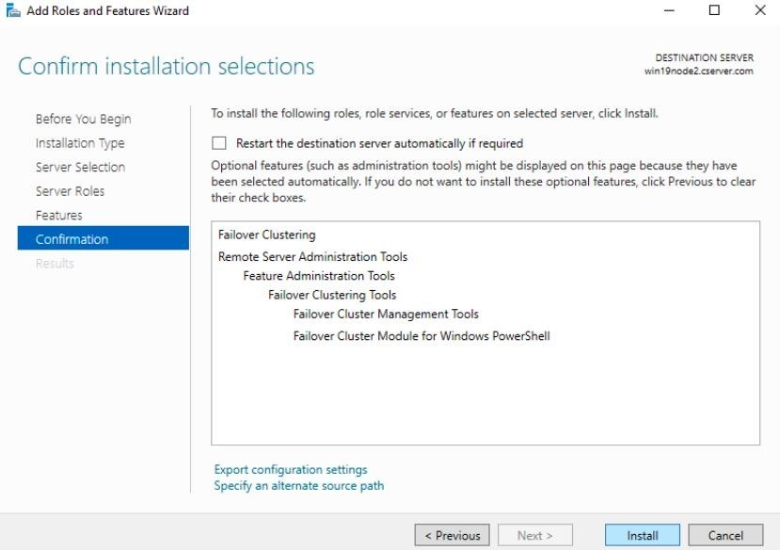  
   **Change the names for node1 to win19node1 and node2 to win19node2 and reboot**

**After rebooting server manager > iscsi Initiator > Click on Yes**

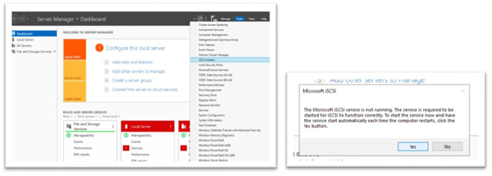

**In the target set the ip to 192.168.1.50 and Quick Connect click ok**

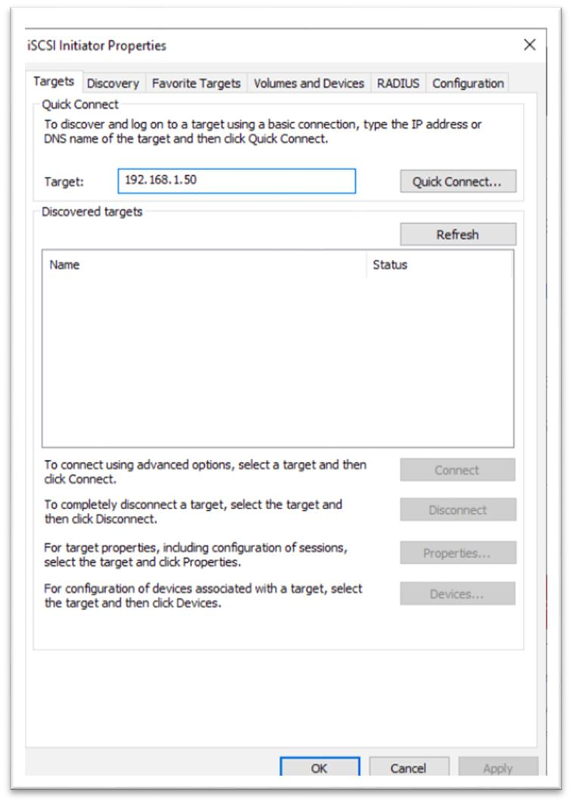  
**After that go to Tools > Computer management > storage > Disk Management**

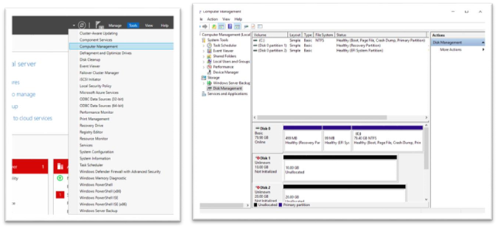

**Click on online in both disks > Disk Initiate > Assign latter > set the volume name to QUORAM and DATA (Set It both the os)**

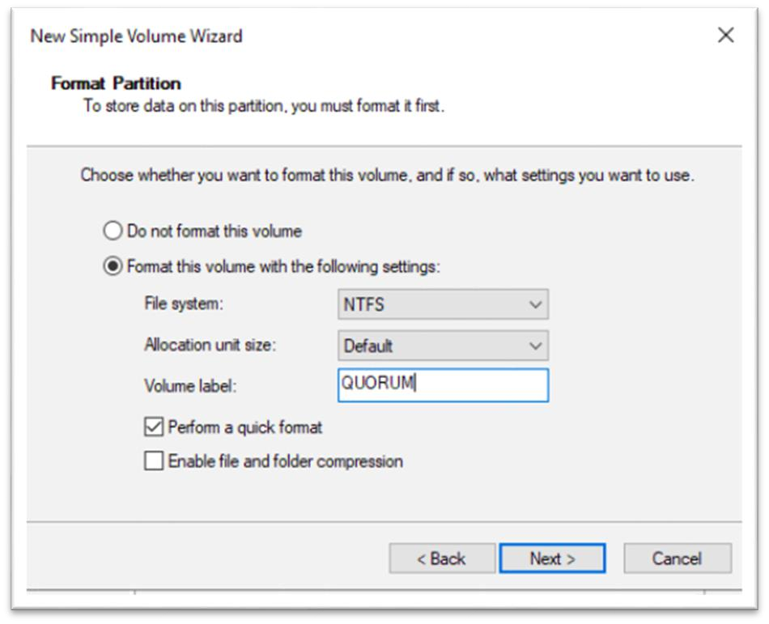  
**Click on online in both disks > Disk Initiate > Assign latter > set the volume name to QUORAM and DATA (Set It both the os)**

**Setup Failover cluster**

1. **Open Any of node os**
2. **Server Manager > Failover Cluster Manager > validate Configuration**

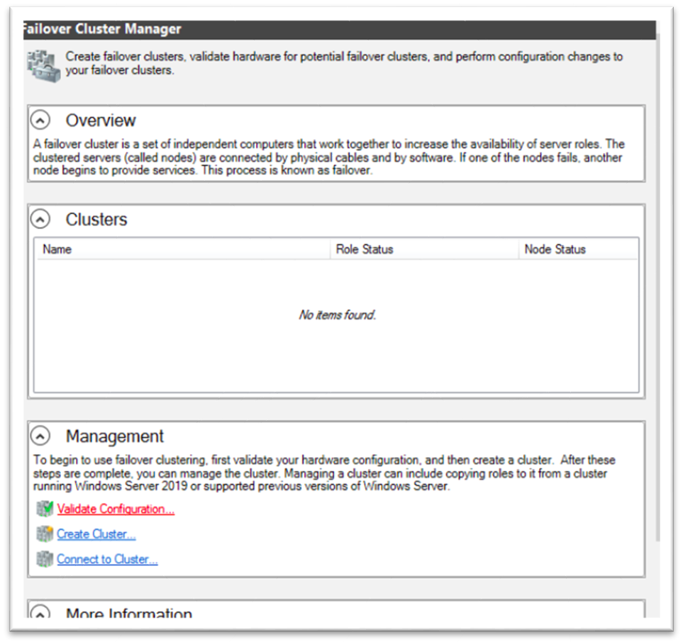  
**Enter node server names and add them**

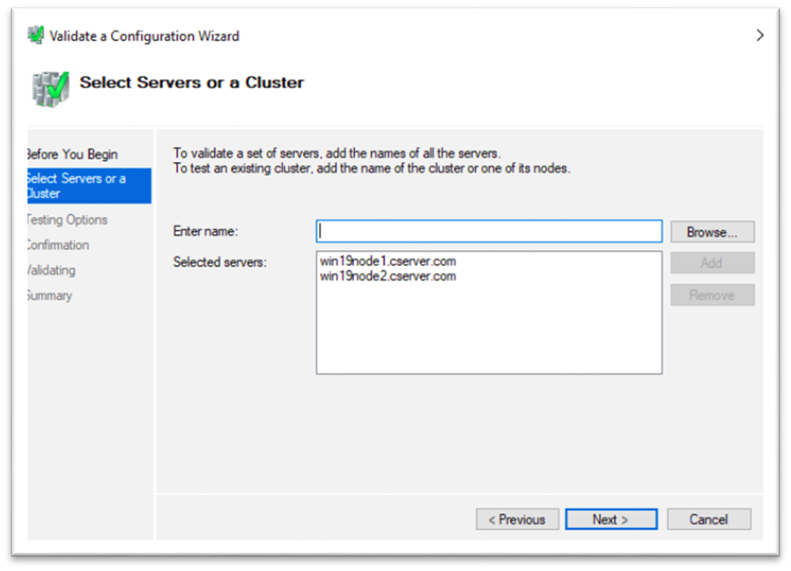  
**Click on run all test and next and check confirmations and start the test by click next, it takes some time to test**

1. 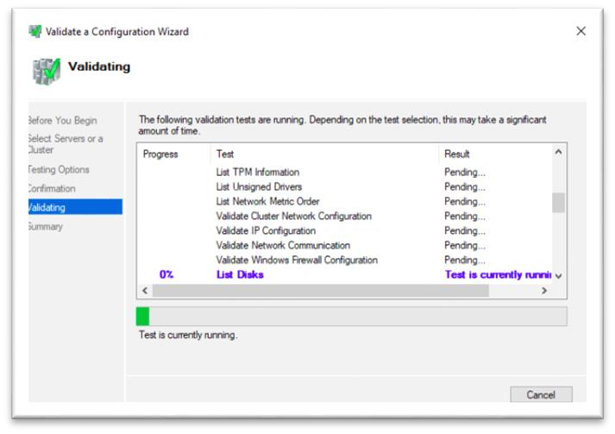  
   **Check all the results and check on create the clusters... and click on finish. It will open another wizard**

**After that set the cluster name and set a cluster ip address**

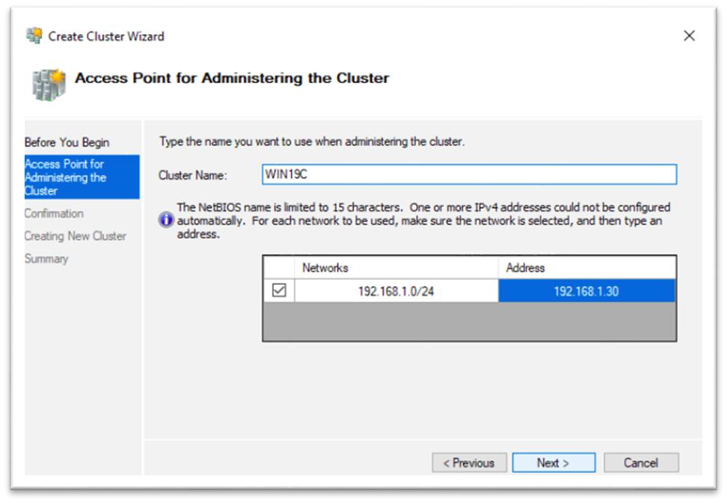  
**Click on next and after that its starts installing**

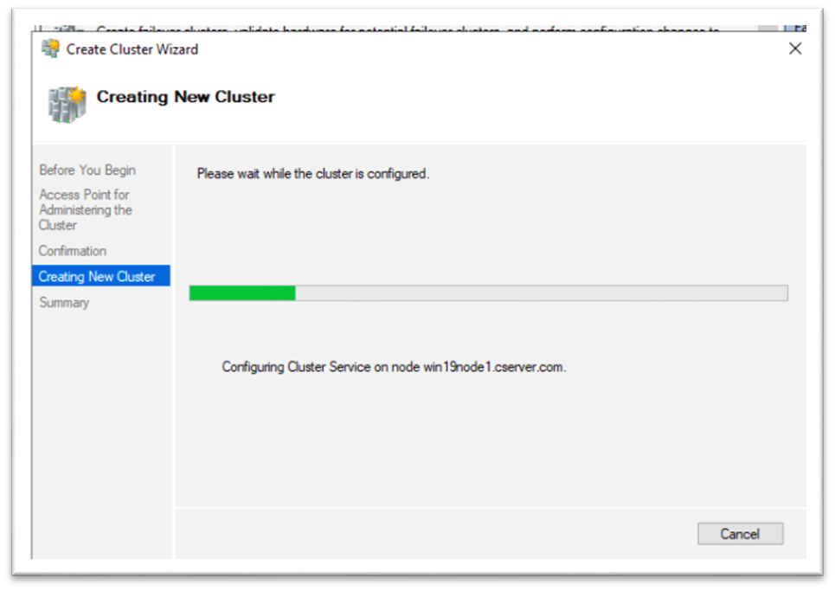  
**Check the installations by ping to the cluster name**  
  
  
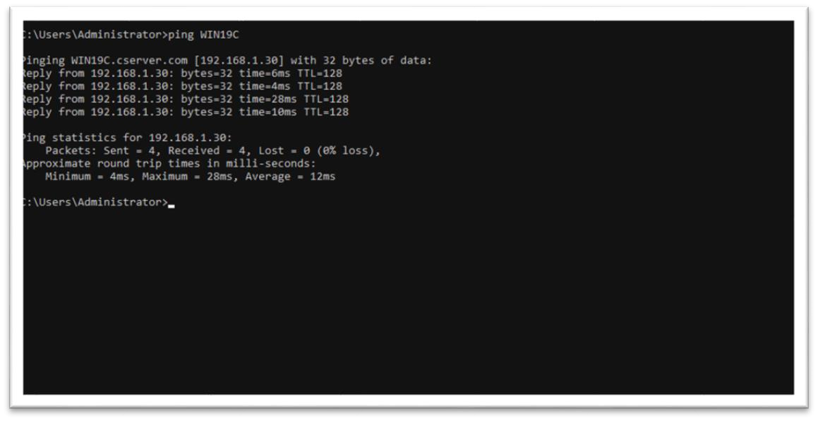

**---The end ----**